Abstract Art
This week I would like you create a piece of abstract art.
Abstract art is art that does not try to represent something that is real, but instead uses shapes, forms and colours to create an effect.
This week I would like you to do some abstract art using a circle.
Look around your house and find an object which is a circle shape that you could use to draw round. I found a roll of tape, a plastic plate, a small bowl, and a cup, but you will be surprised how many circular shapes of different sizes you will find!
On a piece of paper draw around your shape lots of times, overlapping circles in different places.
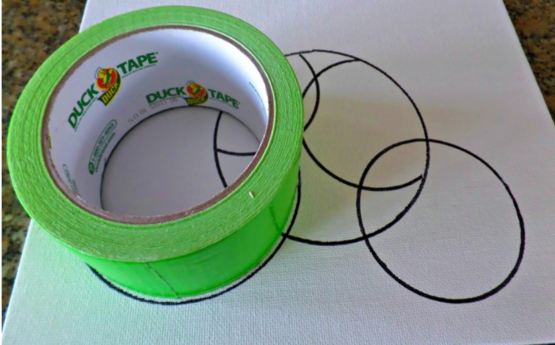
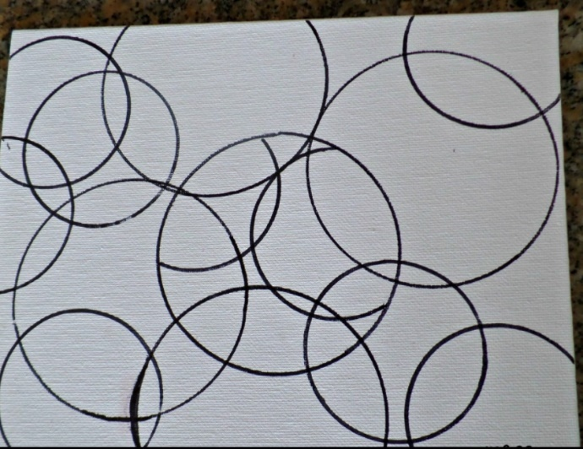
I chose just one circular object, so my circles were all the same size. But you could choose 2 or 3 different sized circular shapes.
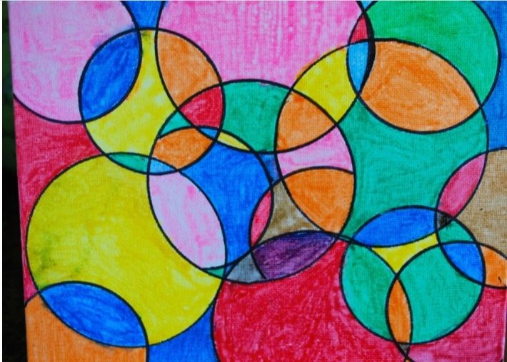
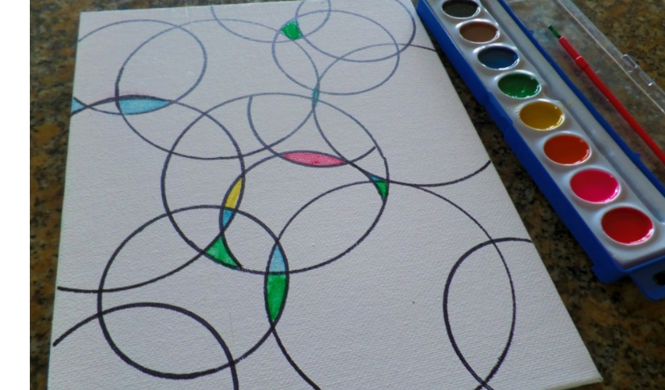

Now colour in the different areas/shapes that you have created. You could use paints, crayons or felt pens.
Challenge: Can you use a different shape? e.g. a square/rectangle
Have fun! I look forward to seeing your work.

